Task 1
- Since it is an intersection of A and B, we only keep what is common. Therefore, it stands to reason that the maximum number of states is at most that of A or B, whichever one of these has the least states is the maximum count. For Kleene star of A, the count remains unchanged. This is because we can do the following: For each accepting state X, and for each state Y where Y is directly reachable from the starting state S, and where X is reachable from Y, add a path that goes from X to Y with the same condition as the path that goes from S to Y.

- The solution to the intersection of A and B is the same as in 1a. Concatenation of A and B results in the total count of states being at most that of the count of states in A plus the count of states in B. We get this by simply transitioning from one to the other via an empty string. However, if there are intersections in letters between words, the total number of states may decrease. Lastly, Kleene star of A can be easily described by an NFA by simply creating a path (consuming an empty string) for each accepting state x that goes from x to the starting state. So, the total amount of states for a Kleene star of A remains unchanged.

- There are infinitely many options, but these are the simplest ones I think:
1. $({\left\{a\right\}}^{*} \backslash \left\{a\right\})×\{b\}×({\left\{c\right\}}^{*} \backslash \{c\})$
2. ${\left\{aa, aaa\right\}}^{*}×\{b\}×{\left\{cc, ccc\right\}}^{*}$
Personally, I prefer the first one, what about you?

- $\left(\left\{q_{0},q_{1},q_{2},q_{3},q_{4}\right\}, \left\{0,1\right\},\left\{\left(\left(q_{0}, 0\right), q_{1}\right), \left(\left(q_{1}, 0\right), q_{1}\right), \left(\left(q_{1}, 1\right), q_{2}\right), \left(\left(q_{2}, 1\right), q_{2}\right), \left(\left(q_{2}, 0\right), q_{1}\right),\left(\left(q_{0}, 1\right), q_{3}\right), \left(\left(q_{3}, 1\right), q_{3}\right), \left(\left(q_{3}, 0\right), q_{4}\right), \left(\left(q_{4}, 0\right), q_{4}\right), \left(\left(q_{4}, 1\right), q_{3}\right)\right\},q_{0},\left\{q_{1},q_{3}\right\}\right)$

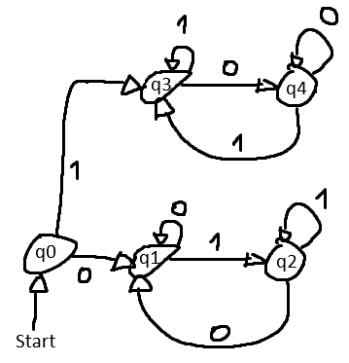
Which is basically the same as my masterpiece on the right. I am not sure how else to describe the δ function, so please give me feedback on whether it is unusual…

Task 2
Remember the definition of the accept state F′ for a conversion from an NFA to a DFA? Well, it is $F'=\{R⊆Q | R contains a state r∈F\}$. All we should do is change it so that
$F^{'}=\left\{R⊆Q \right| R⊆F\}$. Now we accept when all branches accept and not just at least one.

Task 3
To show that the language is not regular via pumping lemma (or PL for short), we must proceed with proof by contradiction. First assume that the language (let’s call it A) is regular, then the PL gives us a pumping length $p$. Now let’s apply the PL by letting the input $w=a^{p}ba^{p}b$. Since $|xy|≤p$, $xy$ consists of only as, and therefore so does $y$ (PL’s 3rd condition). This leads to the first half of $xy^{i}z$ for $i≥2$ to change whilst the second half remains untouched. In the end, we get that the first and second halves are not the same anymore which is a direct contradiction to the definition of A.

